Title: Exchange Rates
Subject: Macro 2
*be precise during exam. Do not write “The exchange rate of the dollar increased” is ambiguous because you could be using the American or the European quotation. Use: “The dollar depreciated against the pound

1. American Vs European Quotations  2. Appreciation  3. Why we need exchange rates  4. Foreign exchange market  5. Uncovered Interest parity Condition  A. Demand for assets  B. Available investment Strategies  C. Equilibrium  a. Arbitarge  b. Undesrtanding the relationship exchange rates-returns  c. Movements along and convergence  D. Shifts  a. Effects of a change in the relative interest rates  b. The effects of changes in expectations on the current exchange rate  E. Empirical Evidence on UIP | The exchange rate is the relative price of two currencies*. Two ways of expressing it:  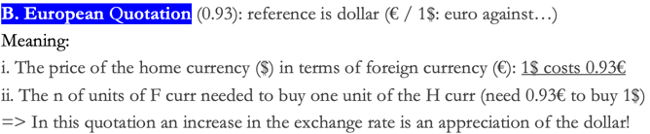  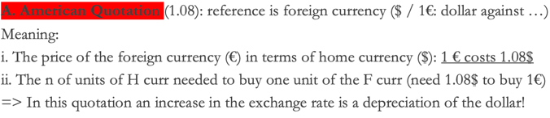  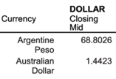  Ex. Is the reference the foreign currency (American quotaiton) or the dollar (European quotation)?  a. If American quotation: reference is foreign b. If European quotation: reference is dollar  i. 1 Peso costs you 68.8 dollars i. 1 dollar costs you 68.8 pesos  ii. or you need 68.8 dollats ot buy 1 pesos ii. or you need 68.8 pesos to buy 1 dolla  => the table is using the European quotation but we will use the American quotation  Appeciation dollar against euro = dollar price of euros decreases = the number of $ needed to buy 1€ decreases  Exchange rates allow us to denominate the cost or price of a good or service in a common currency.  Ex: a British sweater costs £50. An US sweater 40$. What’s relative price?  Multiply price in pound by number of dollars needed to buy a pound = American quotation ($/€)  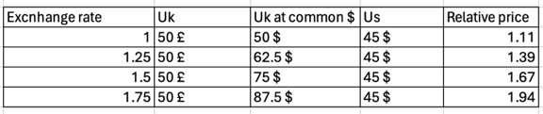  i. A depreciation of us dollar against uk exchange rate  ii. Uk exports cost $↑$ (Uk less competitive), Uk imports cost $↓$  The exchange rates of currencies are determined in the foreign exchange market.  a. The participants:  Commercial banks and corporations, Non-bank financial institutions and Central banks  Why commercial banks operate in the market?  i. First, to fulfill the needs of their corporate customers ( convert payments received by customers in Home currency)  ii. Second, “interbank trading” (accounts for much of the activity in the foreign exchange market).  b. The market:  Biggest single makret in the world, very liquid, Most transactions (88.3% in 2019) are exchanges foreign currencies / U.S. dollars  c. Spot vs forward rates (forward used to hedge)  Spot rates are exchange rates for currency exchanges “on the spot” = for immediate execution.  Forward rates are exchange rates for currency exchanges that will occur at a future (“forward”) date (30, 90, 360 days). Rates are negotiated between two parties in the present, but the exchange occurs in the future.  Ex. Two parties commit themselves on April 1 to a spot exchange of £100,000 for $155,000 on May 1, even if current exchange is 1.52  How forward rates are used to hedge (imagine sell price = 100$):  i. A (Us) has bought ¥9,000 worth of radios from B (Jap). Today the exchange rate is $0.0105 per yen -> cost $94.50 -> 5.5$ profit  ii. Best Buy will not have the funds to pay the supplier until the radios arrive and are sold (30 days)  Fear: Imagine dollar depreciates to $0.0115 per yen -> cost $103.50 -> $3.50 loss  Solution: buy yen forward at 30-days forward rate is $0.0107 -> cost 96.30 --> $3.70 profit  A. Determinants of the demand for an asset  1. expected rate of return, risk of holding the asset, liquidity of the asset  BUT we assume that risk and liquidity of currency deposits in foreign exchan mkts are equal, regardless of the currency of denomination  => Expected rates of return determine how investors move their money  ********** 1  B. Available Strategies  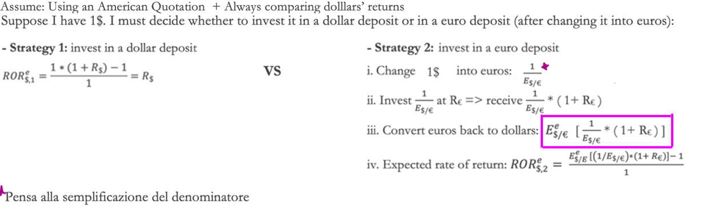  C. Equilibrium (Assume R$, R€ and $E_{\$/€}^{e}$are fixed)  a. Arbitrage guarantees equilibrium: Strategy 1 and Strategy 2 must be equal  *il bonus malus è un banalissimo rate of return! la formula nel complesso una banalissima somma ri rates of return!  Economic rationale of the arbitrage condition:  If the dollar return from a dollar deposit is larger than the dollar return from a euro deposit => nobody wants to hold euros, everybody is trying to sell euros => excess supply of euros and excess demand for dollars = dollar appreciation  b. Current exchange rate–returns relationship  If the current dollar against euro exchange rate depreciates ($E_{\$/€}$) $↑$--> The dollar return of euro deposits ( $\frac{E_{\$/€}^{e}}{E_{\$/€}}$ - 1 ) + R€ $↓$.  Why? The math works + economic rationale: ( $\frac{E_{\$/€}^{e}}{E_{\$/€}}$ - 1 ) is the bonus/malus on top of R€.  i. Bonus: If the dollar against the euro exchange rate appreciates NOW -> Since expectations are fixed we expect a future depreciation -> dollar to euro is worth more today than next year:  - If you invest 1 $ now in euros you will get back more than its current value in one year because 1€ will be worth more dollars.  - Since the dollar is appreciated now = you get more euros for each dollar invested now (euro is cheap) = low cost of buying euros    ii. Malus: exact opposite  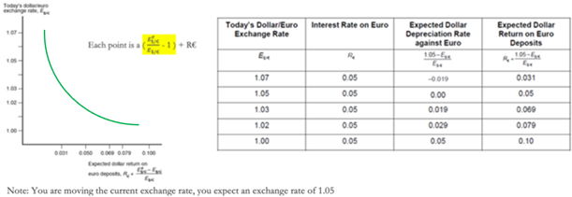  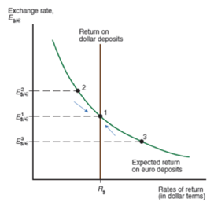  c. Movements along and convergence (arbitrage condition)  Point 2: exp. ret. on € deposits is higher than exp. ret. on $ deposits.  Considering interet rates fixed: here the problem is that the interest on dollar deposits is higher than the interest in euro deposits BUT the exchange rate dollar to euro is too depreciated (not enough appreciated), hence the expected depreciation of the dollar is too small = the bonus is not big enough = the cost of euros is too high => more current depreciation needed  D. Shifts (consider: R$ = ( $\frac{E_{\$/€}^{e}}{E_{\$/€}}$ - 1 ) + R€)  a. Effects of a change in the relative interest rates  Each change in interest rate is compenasated by a change in the exchange rate Such that there is NO arbitrage opportunity for investors!  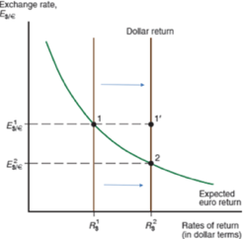  I. The effects of and increase in dollar deposits’ interest rates on the current exchange rate  - (1’) expected dollar return on dollar deposits is higher  - (But 2) exchange rate now (proogressively) adjusts bc ppl do not want to hold €, and will sell euros to get dollars up until the expected dollar return on euro deposits increases to point 2 => hence dollar to euro exchange appreciates BUT we expect a future depreciation of he dollar bc our expected exchange rate level is fixed.  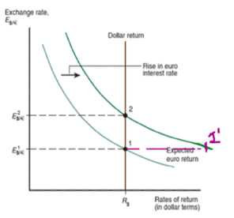  II. The effects of changes in euro deposits interest rates on the current exchange  If you consider the formula: ( $\frac{E_{\$/€}^{e}}{E_{\$/€}}$ - 1 ) + R€ = R$. Increase in + R€ shifts up the curve  - (1’) expected dollar return on euro deposits is higher  - (But 2) you want to sell dollars to buy € => euro appreciates / dollar depreciates up untile the expected dollar return on euro deposits declines ot point 2  b. The effects of changes in expectations on the current exchange rate  If you consider the formula: ( $\frac{E_{\$/€}^{e}}{E_{\$/€}}$ - 1 ) + R€ = R$  Exactly same graph as before: increase in $E_{\$/€}^{e}$ (dollar to expected euro exchange rate depreciation) shifts up the curve = increases the expected dollar return on euro deposits. Expected euro exchange rate depreciation leads to current euro exchange rate depreciation  Why? At the initial exchange rate, the expected return from a euro deposit is higher (you now dollar will depreciate and you want to convert as soon as possible to euros): everybody tries to sell dollar => current exchange rate dollar to euros depreciates  Empirical Evidence on UIP  From the UIP condition, we have learned that if a currency has a higher interest rate it should depreciate over time against a currency with a lower interest rate = by arbitrage, investing in the two currencies should give the same expected return.  Ex. 2000s: Jap i close to 0, Australia positive. The UIP condition implies that the interest advantage of Australian dollars should be wiped out by an appreciation of the yen BUT this did not happened. International investors frequently borrow low- interest currenciesand buy high-interest currencies = Carry Trade.  Hard to understand why UIP does not hold, how can we explain this?  Possible explaination, Investors expectation could be structured in this way:  1% Aus Dollar appreciation at 90% + 40% Aus Dollar depreciation at 10%  => Expected change of the exchange rate of the Australian dollar: -1*0.9 + 40*0.1 = 3.1 expected depreciation (lower than expected)  In breve: CURRENCIES DO NOT DEPRECIATE ENOUGH => BETTER BUY HIGH INTEREST CURRENCIES

